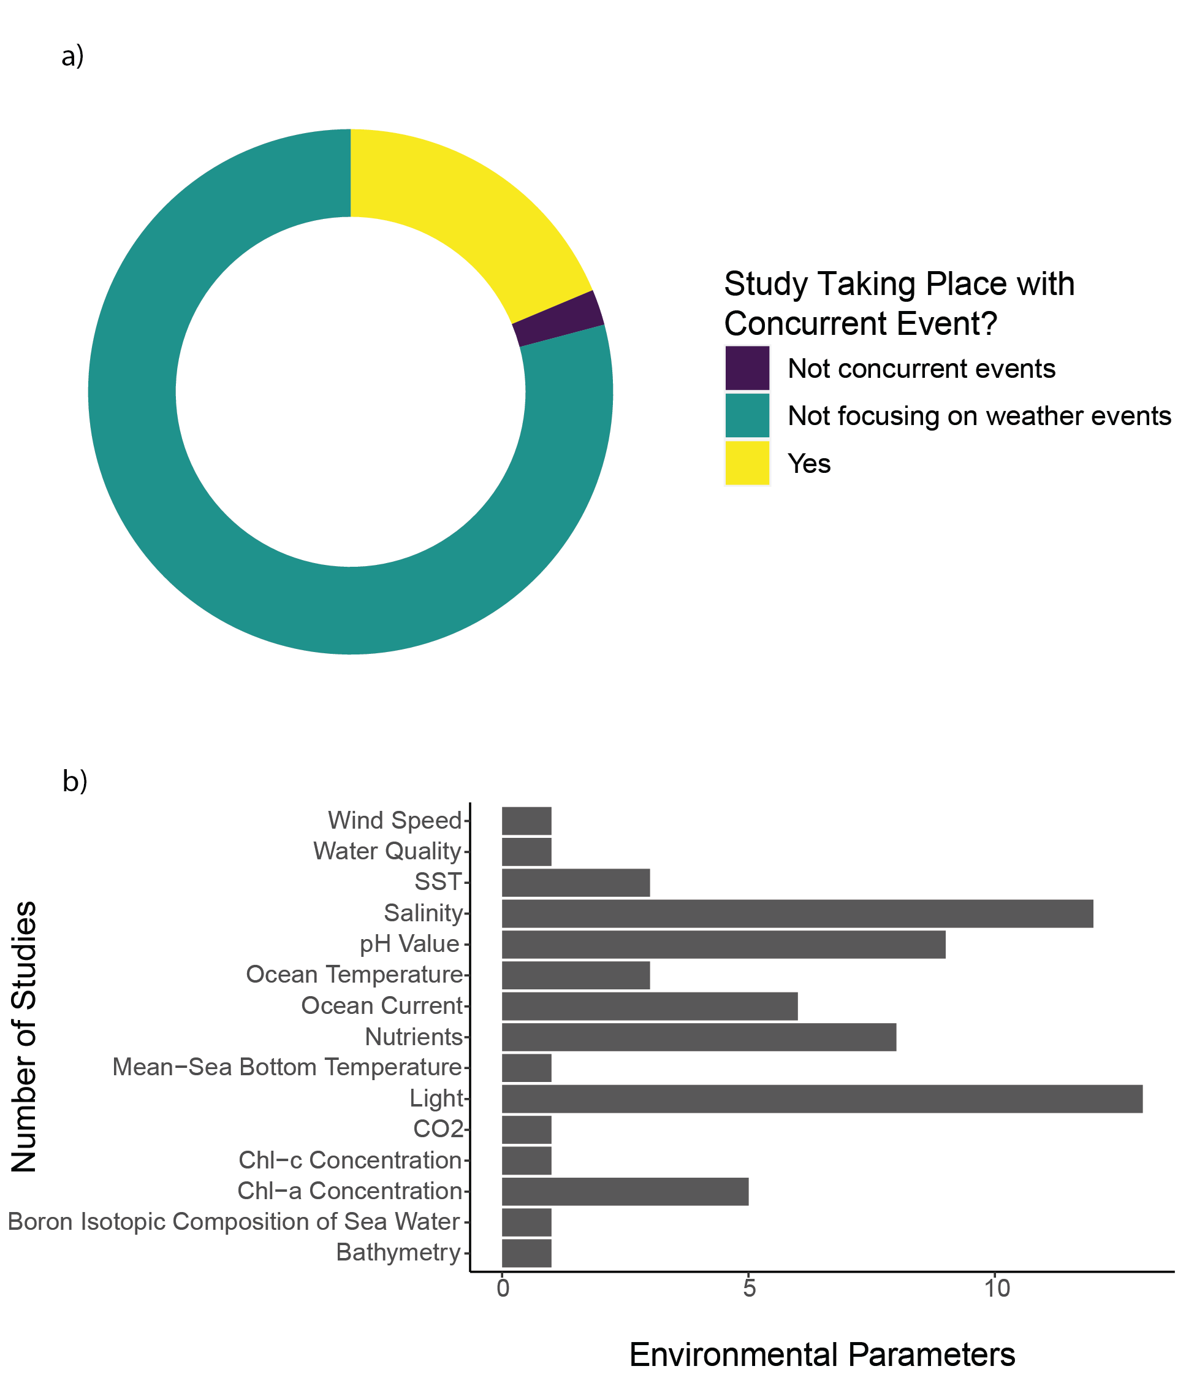

Figure 10a) Portion of publication focusing on weather event, created using R package ggplot2. b) Other parameters recorded in the literature covered in this systematic map, created using R package ggplot2.